RHYTHMIC TUNES: YOUR MELODIC COMPANION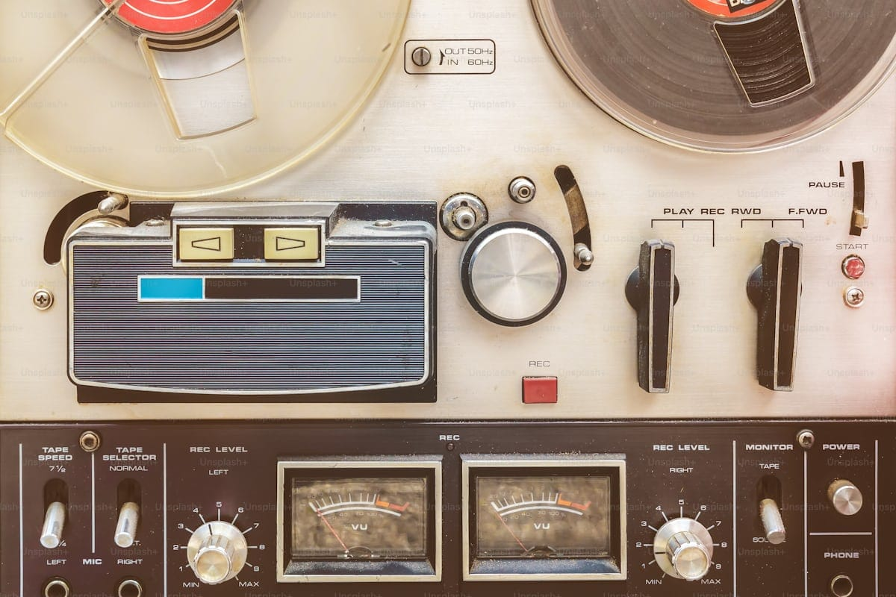

TEAM MEMBERS:

SANJU SHREE

ROHINI

SUGITHA

SAVEETHA SHREE

RAGAVI

INSTITUION NAME:

VALLIAMMAL COLLEGE FOR WOMEN

INTRODUCTION:

* RythimicTunes is not just another music app – it’s your personal gateway to a world of rhythm, melody, and harmony. Built with the power of React.js, RythimicTunes is designed to provide a seamless, engaging, and personalized music experience for users of all kinds.
* From trending hits to timeless classics, RythimicTunes ensures a smooth journey into the soundscape that fits your mood, lifestyle, and taste.

SOURCE CODE:

<!DOCTYPE html>

<html lang="en">

<head>

<meta charset="UTF-8">

<meta name="viewport" content="width=device-width, initial-scale=1.0">

<title>🎵 My Music Player</title>

<style>

body {

font-family: Arial, sans-serif;

background: linear-gradient(135deg, #ff9a9e, #fad0c4, #a18cd1, #fbc2eb);

background-size: 400% 400%;

animation: gradientBG 10s ease infinite;

margin: 0;

padding: 0;

color: white;

}

@keyframes gradientBG {

0% {background-position: 0% 50%;}

50% {background-position: 100% 50%;}

100% {background-position: 0% 50%;}

}

.container {

max-width: 500px;

margin: 50px auto;

background: rgba(0,0,0,0.7);

padding: 20px;

border-radius: 20px;

box-shadow: 0 4px 20px rgba(0,0,0,0.5);

}

h1, h2, h3 {

text-align: center;

margin-bottom: 20px;

}

ul {

list-style: none;

padding: 0;

}

li {

padding: 10px;

margin: 5px 0;

background: rgba(255,255,255,0.1);

border-radius: 10px;

cursor: pointer;

transition: 0.3s;

display: flex;

justify-content: space-between;

align-items: center;

}

li:hover {

background: rgba(255,255,255,0.3);

}

audio {

width: 100%;

margin-top: 20px;

}

input[type="text"] {

width: 100%;

padding: 10px;

margin-bottom: 15px;

border-radius: 10px;

border: none;

}

.fav-btn {

background: gold;

border: none;

padding: 5px 10px;

border-radius: 10px;

cursor: pointer;

font-weight: bold;

}

</style>

</head>

<body>

<div class="container">

<h1>🎶Rhythmic Tunes : Your Melodic Companion🎶</h1>

<h2>My Playlist 🎶</h2>

<!-- Search box -->

<input type="text" id="search" placeholder="Search songs..." onkeyup="filterSongs()">

<!-- Playlist -->

<ul id="playlist">

<li onclick="playSong('C://Users//sanju//Music//rhythmic tunes//songs//ed-sheeran-shape-of-you.mp3','Shape of You (Demo)')">

Shape of You

<button class="fav-btn" onclick="addToFavorites(event, 'C://Users//sanju//Music//rhythmic tunes//songs//ed-sheeran-shape-of-you.mp3','Shape of You (Demo)')">⭐</button>

</li>

<li onclick="playSong('C://Users//sanju//Music//rhythmic tunes//songs//believer_song.mp3','Believer (Demo)')">

Believer

<button class="fav-btn" onclick="addToFavorites(event, 'C://Users//sanju//Music//rhythmic tunes//songs//believer_song.mp3','Believer (Demo)')">⭐</button>

</li>

<li onclick="playSong('C://Users//sanju//Music//rhythmic tunes//songs//die_with_a_smile.mp3','Die with a Smile (Demo)')">

Die with a Smile

<button class="fav-btn" onclick="addToFavorites(event, 'C://Users//sanju//Music//rhythmic tunes//songs//die_with_a_smile.mp3','Die with a Smile (Demo)')">⭐</button>

</li>

<li onclick="playSong('C://Users//sanju//Music//rhythmic tunes//songs//i_wanna_be_free.mp3','Wanna Be free (Demo)')">

Wanna Be Free

<button class="fav-btn" onclick="addToFavorites(event, 'C://Users//sanju//Music//rhythmic tunes//songs//i_wanna_be_free.mp3','Wanna Be free (Demo)')">⭐</button>

</li>

<li onclick="playSong('C://Users//sanju//Music//rhythmic tunes//songs//i_m_sorry_song_by_jk.mp3','I’m Sorry Don’t Leave')">

I’m Sorry Don’t Leave

<button class="fav-btn" onclick="addToFavorites(event, 'C://Users//sanju//Music//rhythmic tunes//songs//i_m_sorry_song_by_jk.mp3','I’m Sorry Don’t Leave')">⭐</button>

</li>

</ul>

<!-- Favorites Section -->

<h2>⭐ Favorites</h2>

<ul id="favorites"></ul>

<h3 id="nowPlaying">Now Playing: None</h3>

<audio id="audioPlayer" controls></audio>

</div>

<!-- Background Music -->

<audio id="bgMusic" autoplay loop hidden>

<source src="https://cdn.pixabay.com/download/audio/2022/03/02/audio_9c29a2f80a.mp3?filename=background-music-116199.mp3" type="audio/mpeg">

</audio>

<script>

function playSong(file, title) {

const player = document.getElementById('audioPlayer');

player.src = file;

player.play();

document.getElementById('nowPlaying').innerText = "Now Playing: " + title;

}

function filterSongs() {

const input = document.getElementById('search').value.toLowerCase();

const songs = document.querySelectorAll('#playlist li');

songs.forEach(song => {

song.style.display = song.innerText.toLowerCase().includes(input) ? "" : "none";

});

}

function addToFavorites(event, file, title) {

event.stopPropagation(); // Prevent song from playing when clicking ⭐

const favList = document.getElementById('favorites');

// Check if already exists

const exists = [...favList.children].some(li => li.dataset.file === file);

if (exists) {

alert(title + " is already in Favorites!");

return;

}

// Create new favorite item

const li = document.createElement('li');

li.innerText = title;

li.dataset.file = file;

li.onclick = () => playSong(file, title);

favList.appendChild(li);

saveFavorites(); // Save to localStorage

}

function saveFavorites() {

const favList = document.getElementById('favorites');

const favorites = [...favList.children].map(li => ({

file: li.dataset.file,

title: li.innerText

}));

localStorage.setItem('favorites', JSON.stringify(favorites));

}

function loadFavorites() {

const saved = localStorage.getItem('favorites');

if (saved) {

const favorites = JSON.parse(saved);

const favList = document.getElementById('favorites');

favorites.forEach(fav => {

const li = document.createElement('li');

li.innerText = fav.title;

li.dataset.file = fav.file;

li.onclick = () => playSong(fav.file, fav.title);

favList.appendChild(li);

});

}

}

// Load favorites when page opens

window.onload = loadFavorites;

</script>

</body>

</html>

OUTPUT:

STRUCTURE OF THE PROJECT:

This project has three main layers:

HTML (Structure / Content) → builds the skeleton (playlist, favourites, audio player, buttons).

CSS (Design / Styling) → makes it look beautiful (colours, animations, layout).

JavaScript (Logic / Functionality) → makes it work (play songs, search, favourites, save data).

FEATURES:

INTERACTIVE EXPERIENCE

Offers dynamic learning through audio-visual aids and guided sessions.

WIDE SONG COLLECTION

From classical ragas to modern hits, the library supports diverse preference.

CUSTOMIZATION

Users can set tempo, rhythm cycles, and tonal variation.

BENEFITS:

LEARNING SUPPORT

Helps beginners grasp rhythm and melody structures step by step.

CREATIVE EXPLORATION

Encourages users to compose, remix, and experiment.

PERFORMANCE AID

Serves as a backing companion during live practice or shows.

THERAPEUTIC VALUE

Music as relaxation aids stress relief and emotional well-being.

CONCLUSION:

Rhythmic tunes is more than an application -it is a musical companion that guides ,supports and inspires.

FUTURE ENCHANCEMENT

AI based personalize music suggestion

Cloud based sharing for composition

Collaborative feature for group practices

DEMO LINK:

https://drive.google.com/file/d/14mFXVSEXwu0uBEGKX6h67SI69rc1hZhH/view?usp=drive_link

REFERENCE LINK:

https://drive.google.com/drive/u/0/folders/1eFtTQ6H6t4uVvml-GEBWwgBq3vQD-w06

